**Microprocessor Lab**

Laboratory Activity No. 2

**Arduino and Tinkercad Interface**

|  |
| --- |
|  |

Score

*Submitted by:*

**Ambalan, John Ace P**

**<Saturday 1:00PM – 4:00 PM> / <CPE 0412.1-2>**

*Date Submitted*

**30-09-2023**

*Submitted to:*

**Engr. Maria Rizette H. Sayo**

I. Objectives

This laboratory activity aims to implement the principles and techniques of hardware programming using Arduino through:

- creating an Arduino programming and circuit diagram.

II. Method/s

- Perform a task problem given in the presentation.

- Write a code and perform an Arduino circuit diagram of a ring counter that display eight (8)LEDs starting from left.

III. Results

**TinkerCad**

**Exercise 1: Write a code that does a ring counter display for eight (8) LEDs starting from left.**

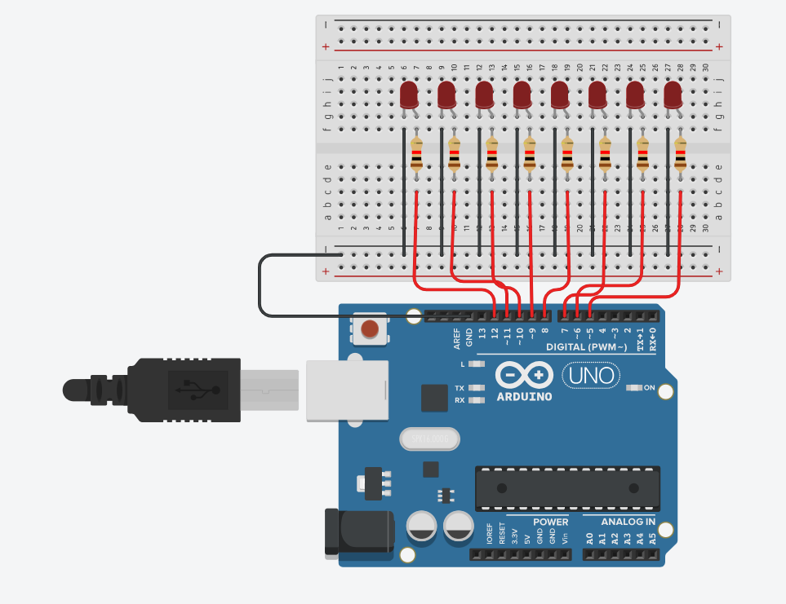

Figure No.1 Ring Counter Display Circuit Diagram

**Components Used**

1. 8 LEDs
2. Resistor
3. Breadboard

**CODE:**

// C++ code

//

/*

Ring counter display for eight (😎 LEDs starting from left.

*/

void setup()

{

Serial.begin(9600);

pinMode(5, OUTPUT);

pinMode(6, OUTPUT);

pinMode(7, OUTPUT);

pinMode(8, OUTPUT);

pinMode(9, OUTPUT);

pinMode(10, OUTPUT);

pinMode(11, OUTPUT);

pinMode(12, OUTPUT);

}

void loop()

{

digitalWrite(12, HIGH);

delay(500);

Serial.println("The LED1 is HIGH");

digitalWrite(12, LOW);

delay(500);

Serial.println("The LED1 is LOW");

digitalWrite(11, HIGH);

delay(500);

Serial.println("The LED2 is HIGH");

digitalWrite(11, LOW);

delay(500);

Serial.println("The LED2 is LOW");

digitalWrite(10, HIGH);

delay(500);

Serial.println("The LED3 is HIGH");

digitalWrite(10, LOW);

delay(500);

Serial.println("The LED3 is LOW");

digitalWrite(9, HIGH);

delay(500);

Serial.println("The LED4 is HIGH");

digitalWrite(9, LOW);

delay(500);

Serial.println("The LED4 is LOW");

digitalWrite(8, HIGH);

delay(500);

Serial.println("The LED5 is HIGH");

digitalWrite(8, LOW);

delay(500);

Serial.println("The LED5 is LOW");

digitalWrite(7, HIGH);

delay(500);

Serial.println("The LED6 is HIGH");

digitalWrite(7, LOW);

delay(500);

Serial.println("The LED6 is LOW");

digitalWrite(6, HIGH);

delay(500);

Serial.println("The LED7 is HIGH");

digitalWrite(6, LOW);

delay(500);

Serial.println("The LED7 is LOW");

digitalWrite(5, HIGH);

delay(500);

Serial.println("The LED8 is HIGH");

digitalWrite(5, LOW);

delay(500);

Serial.println("The LED8 is LOW");

}

Tinkercad Link:

https://www.tinkercad.com/things/kkkPR9VRS4K-lab-2/editel?sharecode=DAnkl8w0mdW24aw1ebOg_hROipPrVWiad6m8epIWAKU

IV. Conclusion

Using Arduino, we were able to construct a sequential LED lighting system in this project. We made a visually appealing light display by connecting 8 LEDs to the Arduino board and programming it to drive the LEDs from left to right. Through this project, we were able to get valuable hands-on practice developing the code required to interface LEDs with Arduino and regulate their behavior.

**References**

StackExchange. *Arduino UNO light LED right-to-left and reversed*. Electrical Engineering. https://electronics.stackexchange.com/questions/17975/arduino-uno-light-leds-right-to-left-and-then-reversed.